**How to Benchmark a HTTP GET Model Website？**

|  |  |  |  |  |  |
| --- | --- | --- | --- | --- | --- |
| No. | Version | Date | Description | Modified By | Document Name |
| 1 | V0.1 | 2023/12/8 | Generate the 1st version | Liushaowei | How to Benchmark a HTTP GET Model Website-v0.1.docx |

## Background

Customer has a static website on Huawei Cloud, in order to evaluate the performance of the website, customer plans to benchmark the website in HTTP GET Request Mode.

According to the best practice of Huawei Cloud, we recommend customer to benchmark the website via WRK2.

If you would like to check the tool list of Huawei Cloud LATAM, please check this site.

<https://github.com/huaweicloud-latam/migration-tool-map>

In this case, customer has only one HTTP GET and Web page. So it’s not necessary to involve the LUAJIT Script, only 1 command is enough for this case.

## Create an ECS with Rocky Linux



## Install WRK2 from Source Code

yum -y install curl-devel expat-devel gettext-devel openssl-devel zlib-devel

yum -y install git

git clone <https://github.com/giltene/wrk2.git>

cd wrk2

make

cp wrk /usr/local/bin

wrk -v

## Start to Test

wrk -t1 -c10 -d20 -R500 -L http://test.tamtesting01.com/ >> result.txt

Remark:

* Thread: 1
* Connection: 10
* Duration: 20
* Request per second: 500

## Generate the graph

This can be plotted via [HdrHistogram Plotter](https://hdrhistogram.github.io/HdrHistogram/plotFiles.html" \t "_blank) to obtain the latency graph.  
The graph for the above report looks like below:



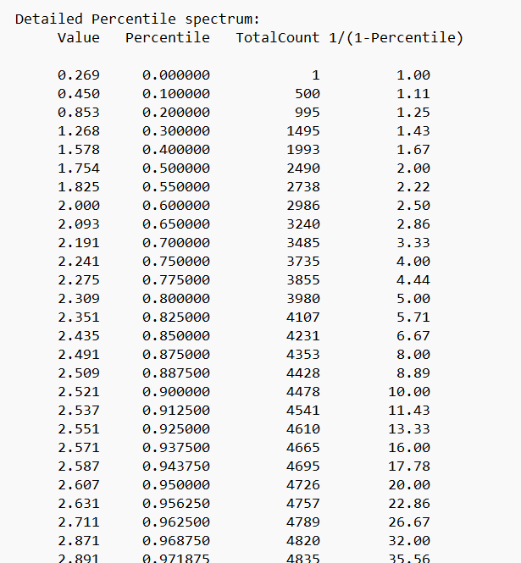

Upload the result file to the HdrHistogram Website.

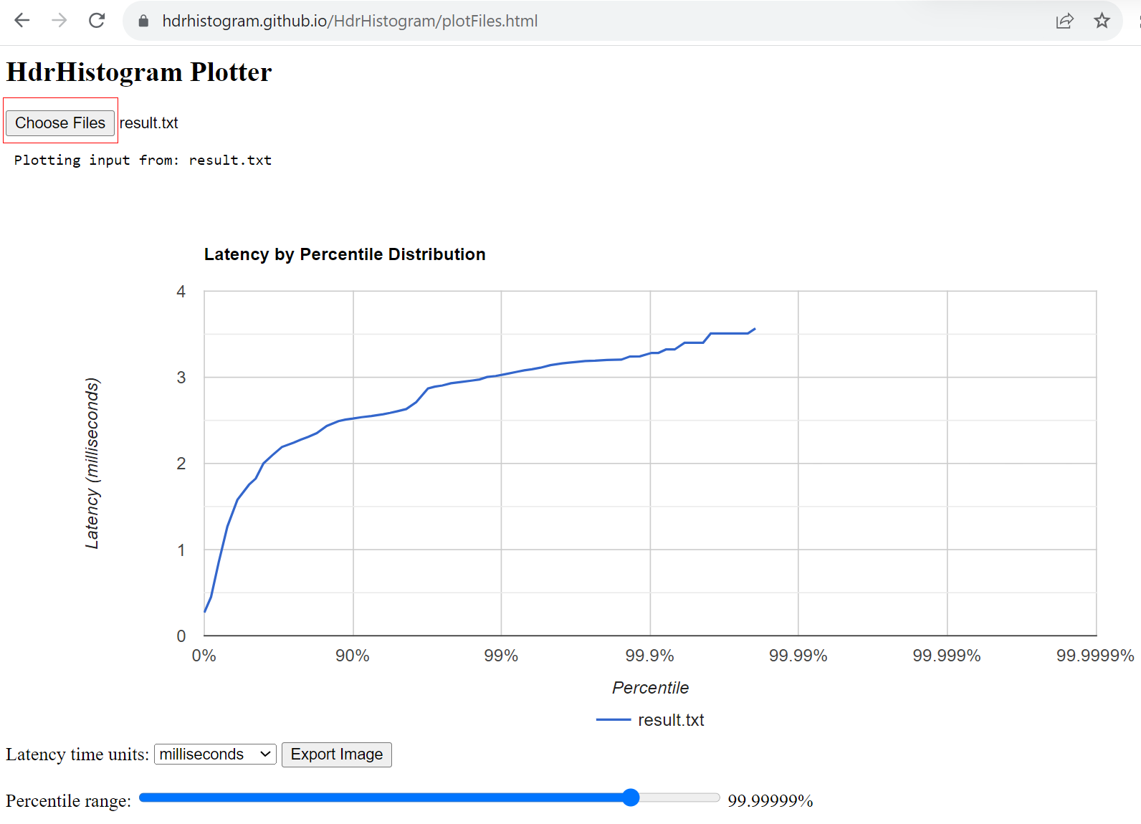

Export the Image.

